Technical Writing Assignment

Renee Romero

How the Web Functions

When one uses a computer and searches in a web browser, such as Firefox or Chrome, and types in the URL (Uniform Resource Locator): www.techtonicgroup.com, there are several actions that occur. Two computers are involved, one called the *client* and the other a *server*. The client is a computer that requests information (meaning - to display the techtonicgroup website on the computer). The other computer is called the server which *has* the information. Another related piece to the client and server is that each of these computers have an IP Address. The IP Address acts similar to social security numbers in how they are used to identify people. The IP Address not only distinguishes each computer but is also used to send and deliver data to the designated computer. The process works like this: when one calls for a website in the URL, the browser interprets numbers or a packet from the client’s IP Address and casts to the network which will eventually be decoded and retrieved from the appropriate server, then channels back a response with the website to the client’s computer.

IP Addresses are synonymous with website names or domains. Because IP Addresses are difficult to recall for humans, its formation changed to text so people could read and remember them. For example, the Techtonic Group website is seen in the URL as: <http://www.techtonicgroup.com>. When applying the client/server process, the browser interprets my computer’s IP Address of 174.16.135.200 and fetches through the network to Techtonic’s IP Address, which is 35.161.60.106. If this process was done prior to 1989, Techtonic’s website would appear in the URL as this: <http://35.161.60.106>. Clicking on these two sites will take the user to the same place. When the user calls for a website, the client and server use a set of specific conventions to communicate which are *protocols*. There are five protocols, and in this scenario, the client-side uses *HTTP* which is known as HyperText Transfer Protocol. In the URL prior to the IP Address, the link begins with “HTTP,” which is applicable for browsing webpages.

Webpages are displayed in browsers and created for client-side-users to view information from a site. Webpages are coded in HTML (HyperText Markup Language), CSS (Cascading Style Sheets) and JS (JavaScript). On the server-side and because it has a different purpose of serving webpages, it uses other technologies and languages such as: a web server, a database, and other languages (e.g. PHP, Java, C#, and more.). The database collects data that the server programmed specifically to be stored. In this case of the Techtonic Group site, there are two webpages that store information from the client-side-user’s interface, which are from the *Contact Form* and *Apprenticeship Form*. The user interacts with these pages and enters: name, email address, phone number (and short message in the Contact Form), then collects to the database.

The process looks like this:

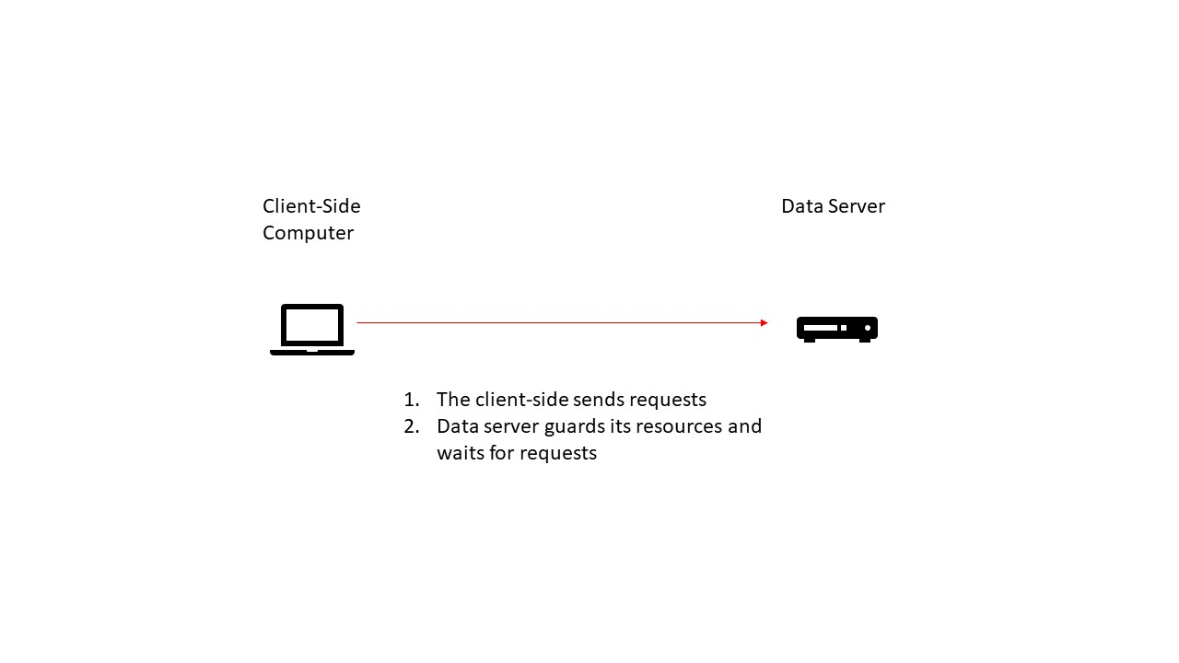

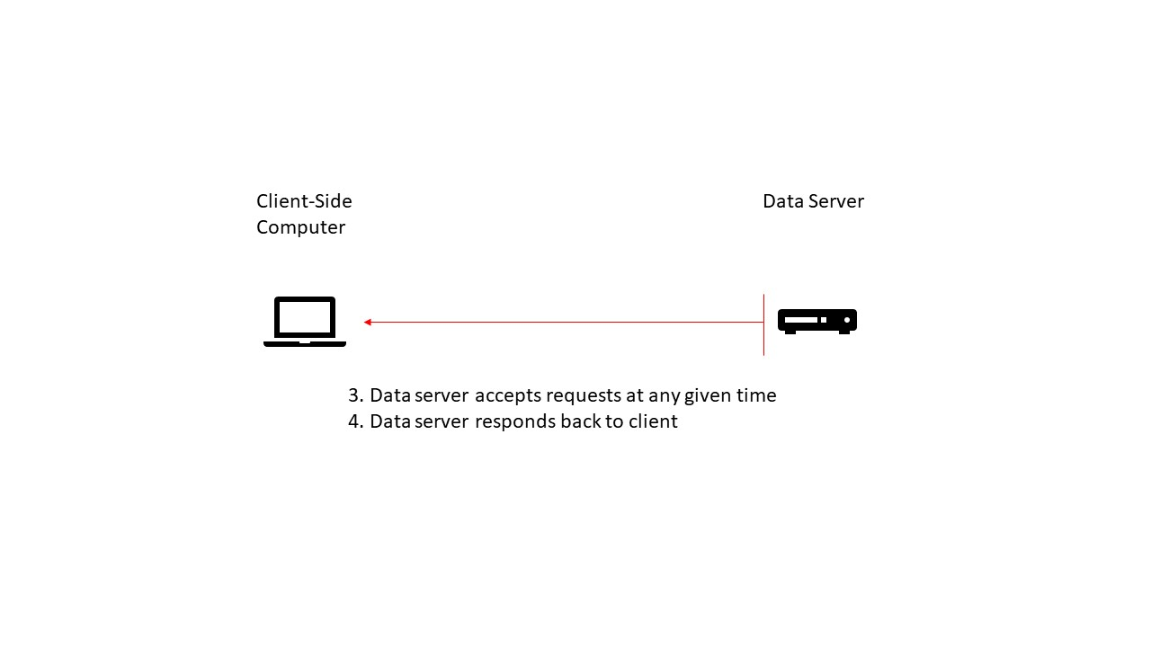

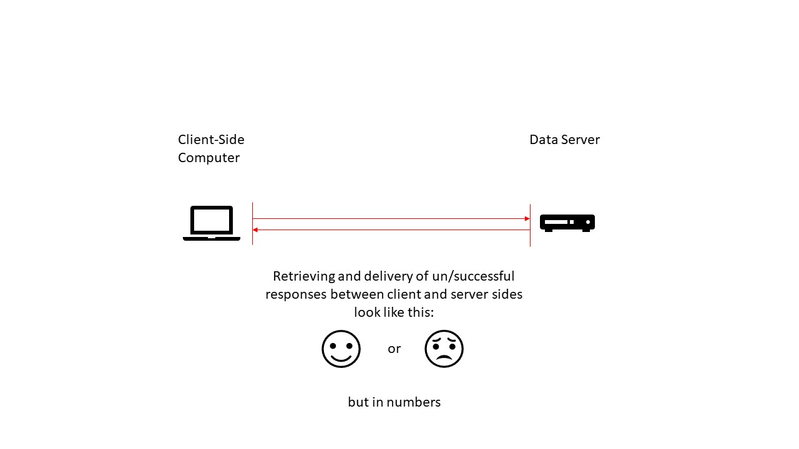

In my evaluation, one instance of the client-side assets is created when requesting webpage, techtonicgroup.com. Regarding instances of the server-side code, available, would be infinite; due to any given time, a client-user, can request that webpage. One instance of the database is connected to the server’s application that keeps data accurate and secure. The run time to complete requests and send responses are performed in milliseconds. Amazingly fast!